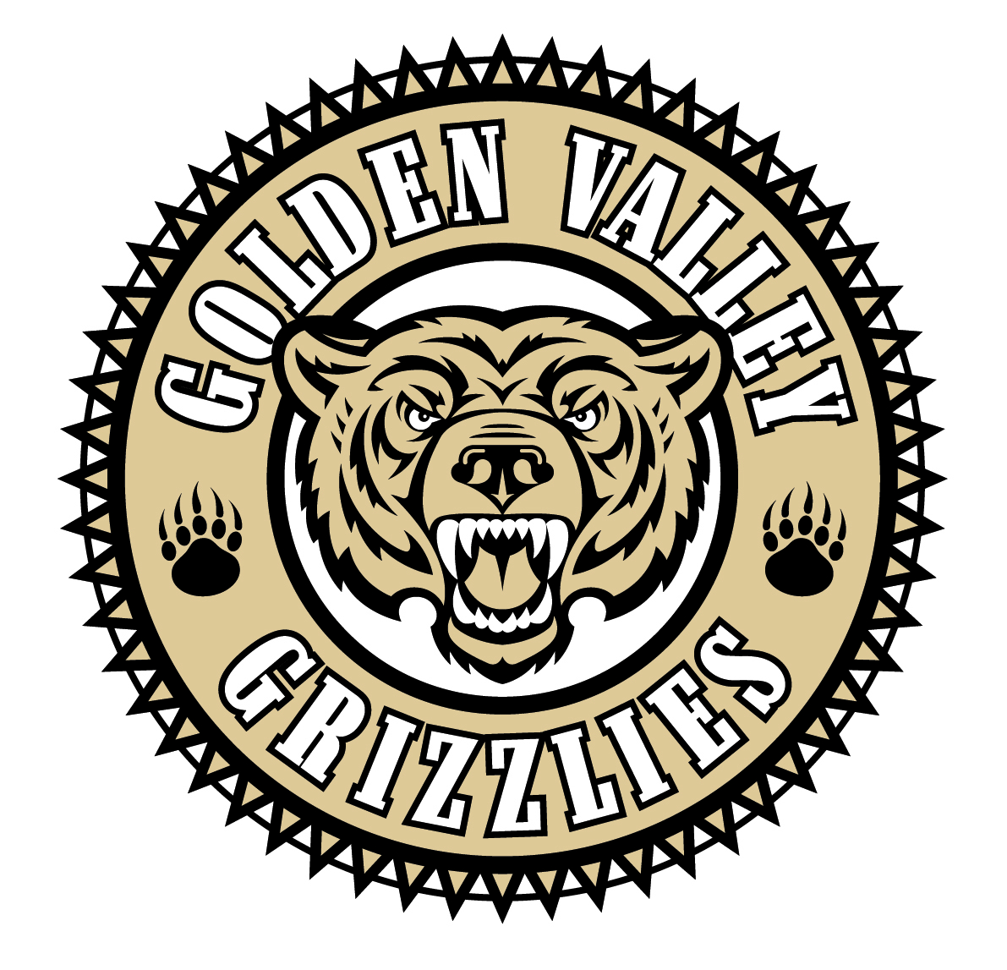
Golden Valley High School
Wm. S. Hart Union High School District
“Home of the Grizzlies”
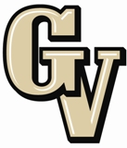

Parent Advisory Council (PAC) Meeting
Dec. 7, 2015
6:00 PM
Canyon Country Community Center
18792 Flying Tiger Drive

AGENDA

- PAC Meeting Welcome Sal Frias

- Secretary’s Report ACTION Monica Camacho

- Treasurer’s Report ACTION Emily Curtis

- President’s Report Sue Alterman

- District Advisory Council (DAC) Report Colleen Villani

- Parent Communications Council (PCC) Report Suzanne Holmes

- Fine Arts Department Kerri Riccio

- Special Education Department Dan Kingery

7:00 pm PAWS Presents
“Do you know what your kids know?” Detective Velek

Announcements: - Baseball Dinner Night 12/9 at The Habit
- GV Choir Winter Concert 12/10 @ 7 pm in the GVHS Theatre
- GV Red Cross Club Blood Drive 12/14 8 am to 2 pm in Aux Gym
- GVHS Band Holiday Concert 12/17 @ 7 pm in the GVHS Theatre
- First Semester Finals Tuesday – Thursday, 12/15 – 12/17 (2/5; 3/6; 4/7) First period starts on Friday 12/11 or sooner if needed)
- Winter Break is from 12/18 to 1/8/16
- Martin Luther King Holiday is 1/18/16
- GVHS Counseling Department Presents a Financial Aide Workshop on 1/20/16 @ GVHS

Next Meeting: January 25th @ 6:30 pm at GVHS Library

The mission of GVHS is to provide a quality education to a diverse student population, develop each student’s maximum potential, and prepare students for success in the global community.

